1. Affordances

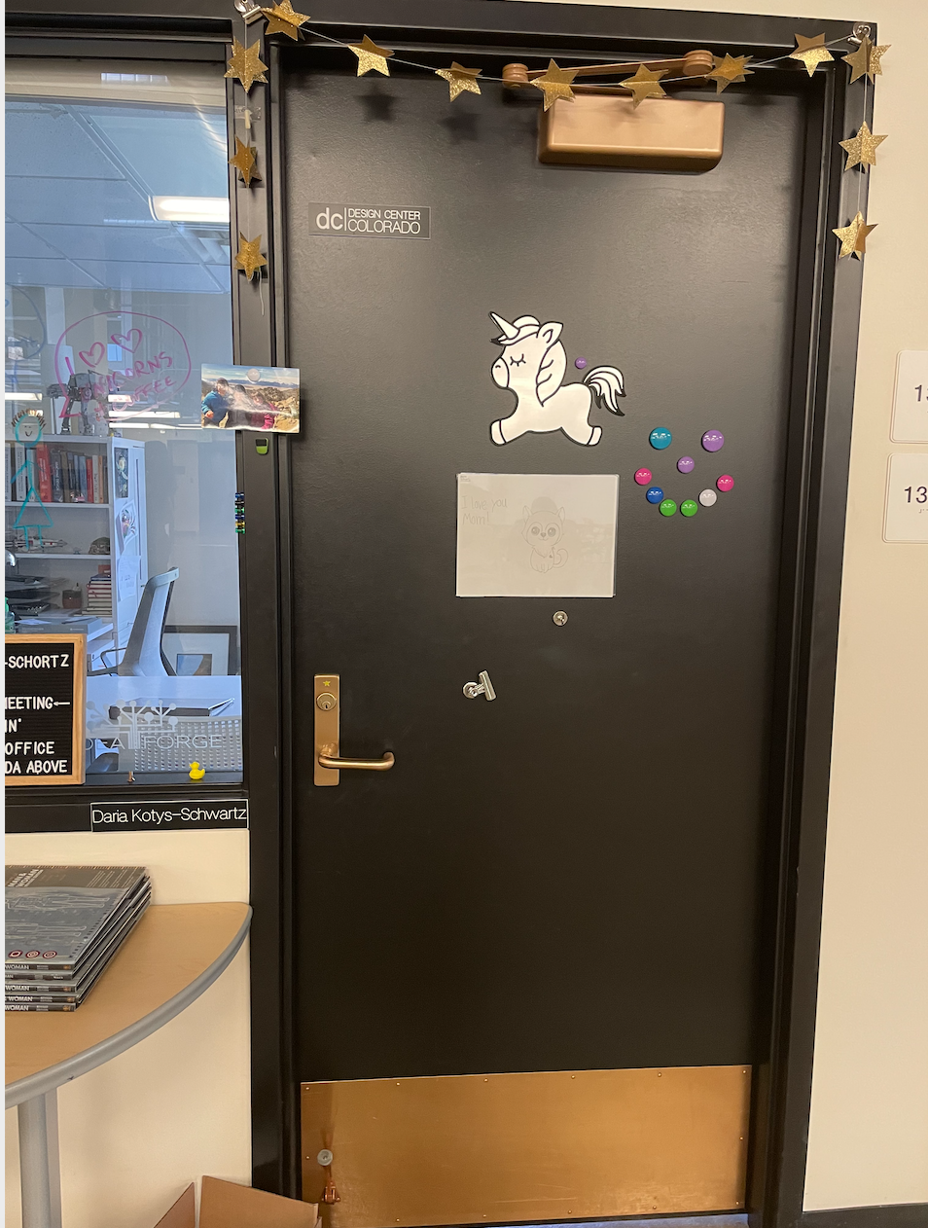 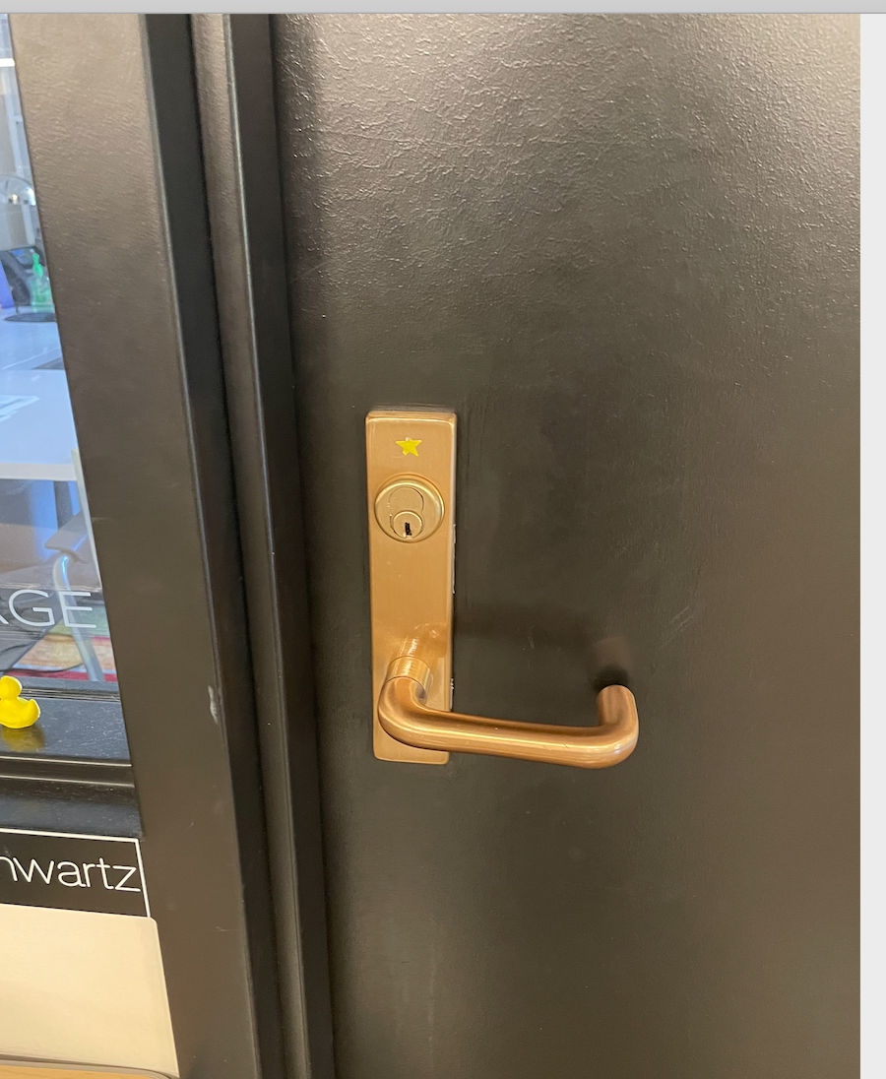

The door handle on the door. Users could push the handle to open the door.

1. Signifiers

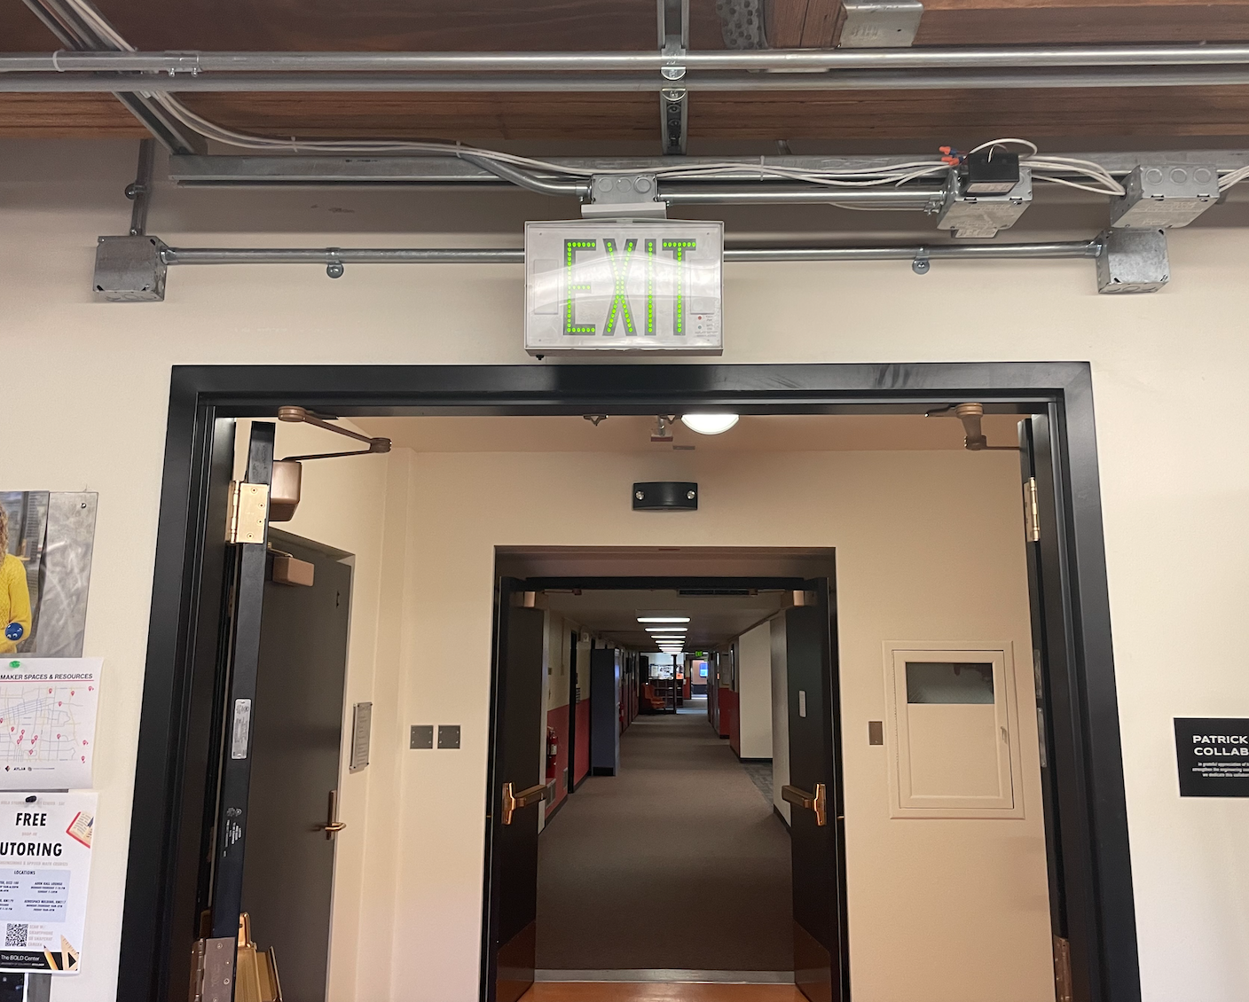 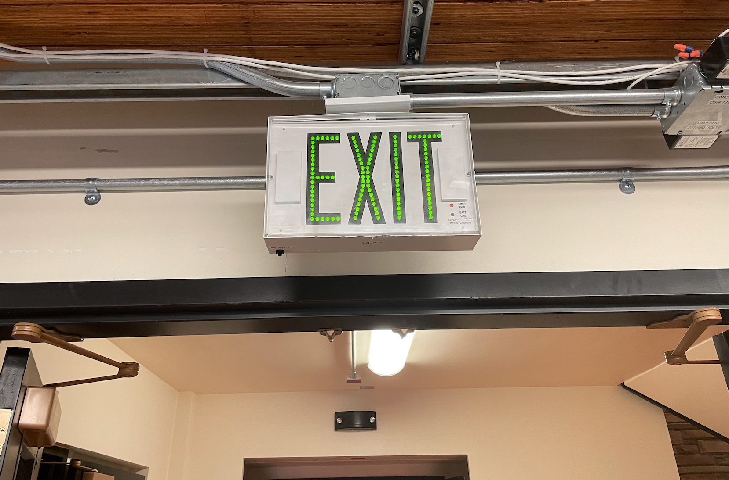

The exit sign at the Fleming building. This tells the instruction how to exit the building.

1. system status/feedback

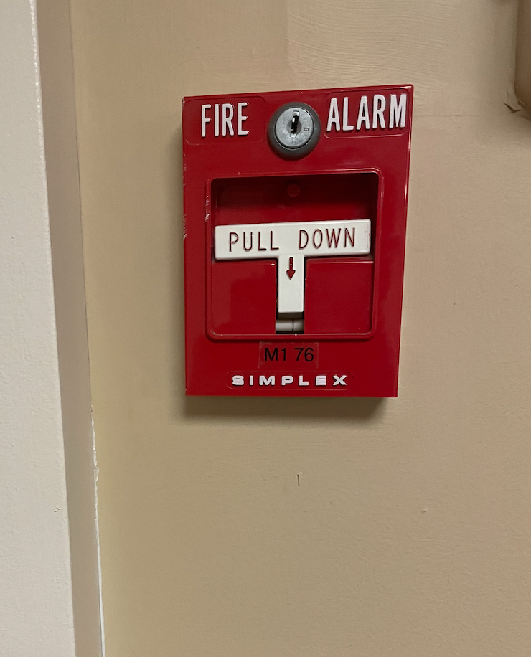

The fire alarm handle. By pushing down the handle, it will give feedback that the fire alarm starts to ring.

1. Constraints

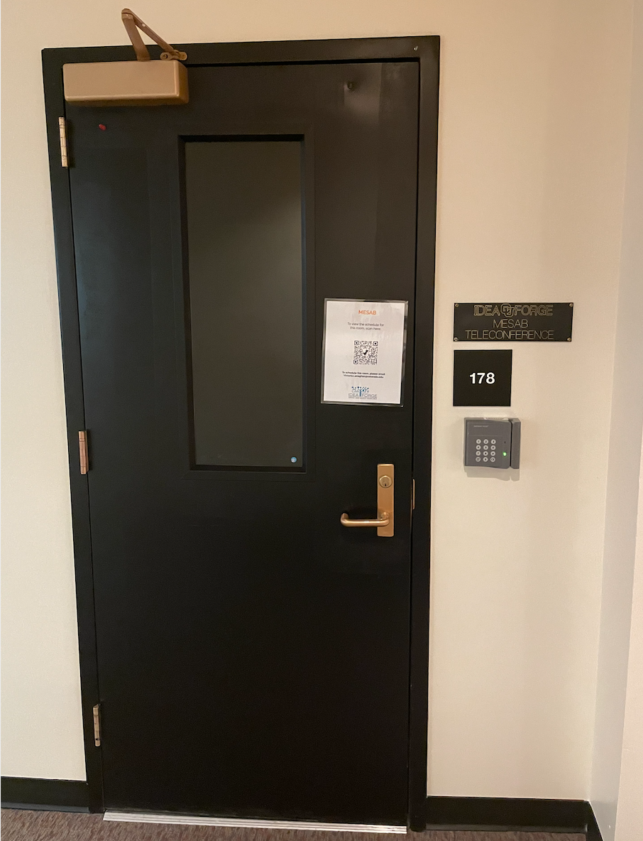 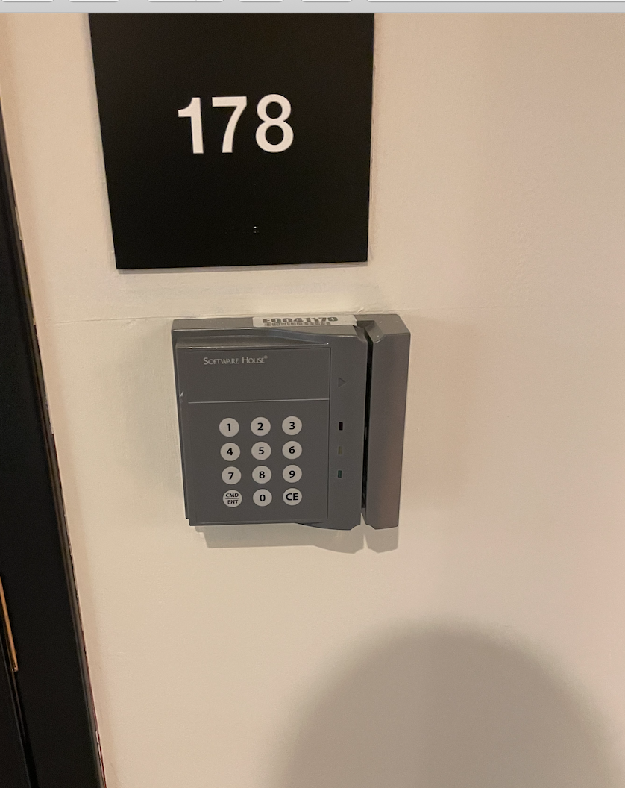

The password board contains unauthorized people from entering the building. People must enter the password or swipe the ID card to enter the room.

1. Mapping

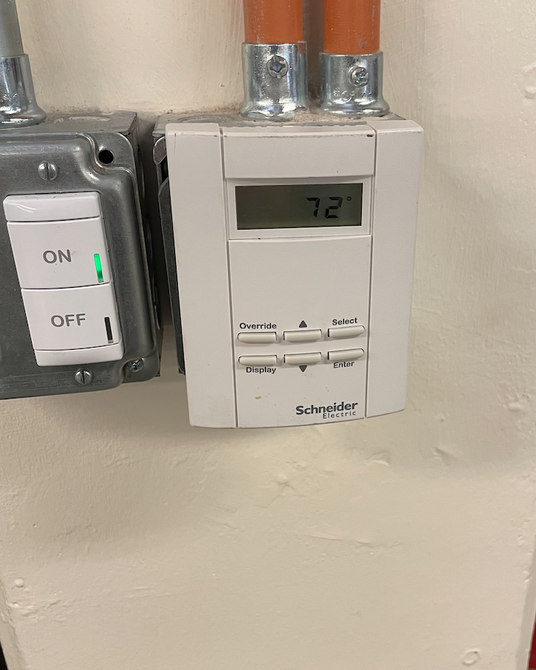

The air conditioner control panel controls the temperature of the room. Users can adjust the temperature rise or fall of the room through the control panel.